Incident Response Report

Summary
- Severity: Critical
- Priority: P1
- Asset(s) Affected: User workstation(s) running Windows OS, Security application (specific application uninstalled) and Domain Controller (potential compromise due to hash dumping).
- Incident Owner: Sebastian Salas
- Contact Information: sebasala@ensign.edu

Incident Timeline

The incident began with a user downloading and opening a macro-enabled Excel file, triggering malicious macros for initial access. A Word document was also executed, leading to a command prompt reaching an unknown IP, likely for Command-and-Control (C2) communication or further malware download. The attacker downloaded and executed a malicious payload (*a.exe*), followed by mounting an ISO file containing a script that executed another program. Using WMIC, the attacker uninstalled a security application to evade detection and subsequently dumped password hashes from the LSASS process for credential theft and lateral movement. These actions suggest a targeted attack employing phishing, security evasion, and credential dumping techniques to compromise the network. Immediate containment, remediation, and investigation are critical to mitigate further impact.

Triage and Analysis
Incident Overview:
- Description: The system executed two suspicious commands using the Windows Command Processor (cmd.exe), which invoked a PowerShell script to download and execute Invoke-Mimikatz, a tool designed for credential dumping, from a remote GitHub URL.
- Detection Method: Wazuh, using Sysmon logs, triggered alerts based on command-line anomalies. Both events involved cmd.exe processes executed by the system (NT AUTHORITY\SYSTEM) with abnormal parent processes (splunkd.exe).

Indicators of Compromise (IOCs):
- Command-Line Arguments:
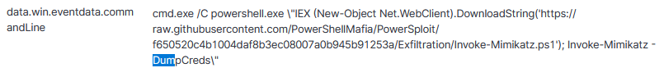

- Parent Process:
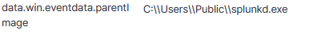

Process Information:
- cmd.exe located at C:\Windows\System32\cmd.exe
- Parent process: C:\Users\Public\splunkd.exe (which may be an abnormal or compromised process).
URLs:
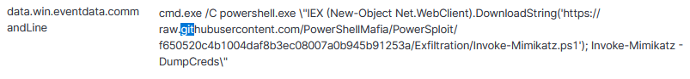

Scope and Impact:
- Scope: Internal system (winterfell) is involved; potential credential theft via Mimikatz tool.
- Impact: Possible compromise of sensitive credentials and system integrity.

Timestamps:
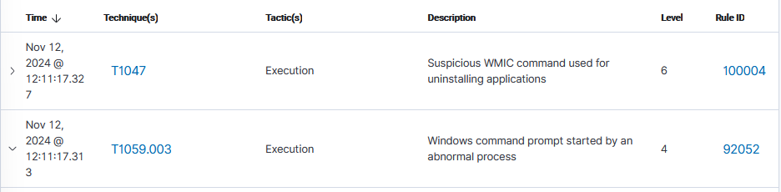
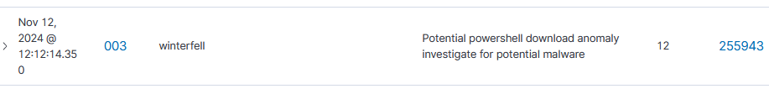

Containment and Neutralization (Short-term/Triage)
- Disconnect affected systems or isolate them with VLANs.
- Block malicious IP addresses to stop further communication.
- End harmful processes and remove suspicious files.
- Revoke admin access and watch for unusual network activity.
- Suspend affected user accounts and reset their passwords.
- Use endpoint protection tools to scan and remove malware.
- Enforce two-factor authentication (2FA) for added account security.

Recovery and Vulnerability Remediation
- System Recovery: Restore affected systems from clean backups, reinstall operating systems and applications, and validate system integrity.
- Enhanced Monitoring: Deploy tools to monitor restored systems for unusual activity.
- Vulnerability Assessment: Identify exploited vulnerabilities, patch software, and harden security controls.
- Testing: Conduct penetration testing to ensure vulnerabilities are fully addressed.
- Stakeholder Communication: Notify stakeholders of the incident and recovery actions, engage external experts if needed, and report to regulatory authorities if required.
- Transparency: Provide regular updates to stakeholders to maintain trust and confidence.

Hardening and Detection Improvements (Lessons Learned, Long-term Response)
- Long-Term Mitigation: Strengthen endpoint protection with EDR, implement Zero Trust architecture, segment networks, and improve patch management.
- Security Awareness: Provide regular training on phishing and security best practices.
- Application Whitelisting: Limit unauthorized application execution.
- Detection Improvements: Upgrade IDS/IPS and SIEM tools, implement behavioral analysis, and enhance centralized logging and alerting.
- Red Teaming and Automation: Conduct regular red team exercises and implement automated response workflows for quicker threat neutralization.

